**Isometric torque values for artificial knee using braided pneumatic actuators**

Ben P. Bolen1, Lindie Burgess1, Connor Morrow1, and Alexander J. Hunt1

1Dept. of Mechanical and Materials Engineering, Portland State University, Portland, OR

email: [bbolen83@gmail.com](mailto:bbolen83@gmail.com)

**Introduction**

Neural control of locomotion is a complex process of sensing, processing, and acting that is not well understood. Greater understanding necessitates modelling biomechanics and neural circuits, and investigating how interactions between the nervous system, the body, and the environment result in effective movement and behaviours. Some of our previous work [1] has been to design, from a biomechancial and engineering design approach, a bipedal biomimetic humanoid robot that is actuated by Festo-brand braided pneumatic actuators (BPAs), or artificial muscles. BPAs can be used as artificial muscles because they have force-length curves grossly similar to real muscle, are compliant, and can only pull, not push.

In our current work we build part of that robot (the knee, femur, and tibia), with uniarticular knee flexor and extensor BPAs, to test for the maximum isometric torque about the knee joint at various knee positions. We will compare the measured isometric torque values about the knee joint with the calculated theoretical values.

**Methods**

The artificial leg consists of 3D printed bone components and two BPAs. One of the BPAs is configured as a knee flexor, and the other is a knee extensor muscle. The knee is a rotating and translating joint designed by Steele [2]. A CALT-100 kg force sensor is tied to the swing arm of the testing jig on one end and the tibia on the other end. The jig is positioned so that the sagittal plane of the leg is parallel with the floor to negate the effect of gravity. A winch is used to move and lock the swing arm so that the knee can be tested at different angles. Force data is collected from the force sensor using a load cell amplified, Arduino Due, and Matlab 2020b.

Images of the test set up are taken with the rear camera of a Samsung Galaxy S10+. These images are then processed in Hugin to eliminate any perspective and barrel distortion. After this, FIJI (Fiji Is Just Imagej) is used to measure the angle of the knee, the moment arm length, and the angle of the force cell to the tibia. This information allows for the calculation of isometric force values. Theoretical isometric force and torque values are calculated in the same way as we laid out in our previous work [1].

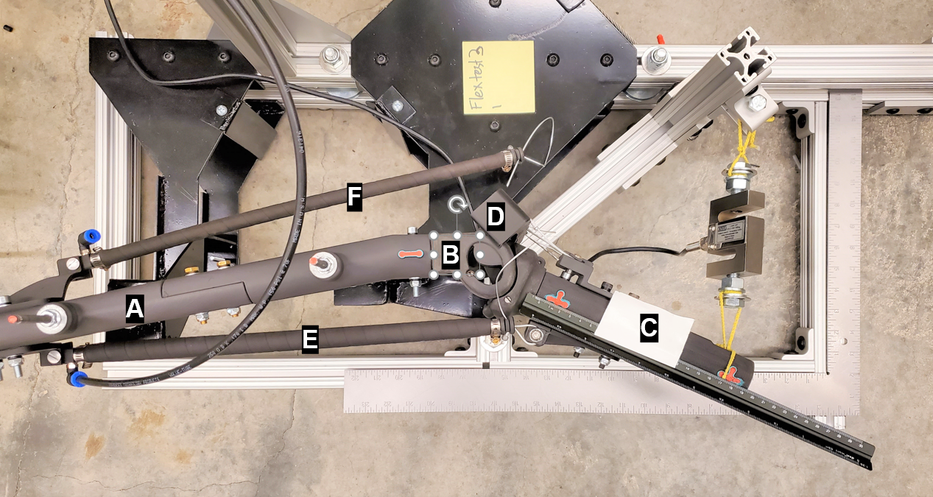

**Figure 1**: Artificial leg with femur (A), knee (B), tibia (C), patella (D), knee flexor BPA (E), and knee extensor BPA (F). The picture shows the artificial leg set up to test for isometric torque from the knee flexor BPA.

**Results and Discussion**

The results show that the calculated and theoretical values for the BPAs are similar over their active range of motion. The muscle diameter and attachment locations do not allow for the isometric torque of the artificial muscle and human muscle to match in the current design configuration. This was predicted by the theoretical model.



**Figure 2**: Comparison of calculated, measured, and human knee torque values.

The results of these experiments help in better modelling and designing biomimetic humanoid robots. Future work will integrate these robots with neural controllers and feedback. Much of this current work revolves around humanoid robots but the results are broadly applicable to other biomimetic robots that use BPAs.

**Significance**

Now that there is an isometric test apparatus for BPA powered biomimetic robots, more testing can be done with other artificial muscle arrangements. Future works can also now be performed on different methods of measuring muscle moment arms.

**Acknowledgments**

NSF grant for NeuroNex: C3NS #2015317

NIH BUILD EXITO grant numbers 5RL5GM118963-06,

5TL4GM118965-06, 5RL5GM118963-07, and

5TL4GM118965-07

**References**

1. Bolen, Ben P., and Alexander J. Hunt. "Determination of artificial muscle placement for biomimetic humanoid robot legs." Conference on Biomimetic and Biohybrid Systems. Springer, Cham, 2019.

2. Steele, Alexander G., Alexander Hunt, and Appolinaire C. Etoundi. "Biomimetic knee design to improve joint torque and life for bipedal robotics." Annual Conference Towards Autonomous Robotic Systems. Springer, Cham, 2018.